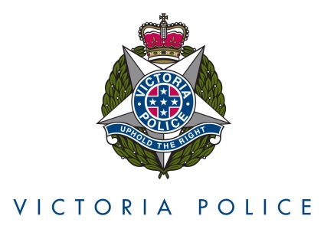

How to submit a Public Advocate’s Award Nomination
To submit a nomination for the Victoria Police Public Advocate’s Awards 2019, please complete the following steps:

- Save a copy of the relevant Nomination Form:
  - Community Nomination is to be completed by any member of the community nominating a Victoria Police employee, police station or work unit.
  - Victoria Police Nomination is to be completed by any employee of Victoria Police nominating another Victoria Police employee, police station or work unit
Note that the form can be completed by someone on your behalf.

- Complete all sections of the form providing your details (Your Name, Email and Phone Number) and details of the person or unit you are nominating (Nominee’s Name or Unit and Work Location). Work Location means police station, suburb, department or any other information that will allow us to match your nomination with the right person/unit. If you are not sure, you may leave this blank and we will follow up with you post-nomination. Click in to the white areas of the form to input information for each of the above sections.

- Provide information about the nomination in the white area of the Description section of the form. Provide enough details to describe what the person/unit has achieved and the impact that these actions have had on people with disability, either as members of the public or as employees of Victoria Police. The impact might be in relation to one individual, a group or to the community in general.

- You are welcome to attach any supporting evidence (e.g. an email or letter) that could strengthen the nomination. Please ensure that all documents are suitable for public use. If this is not possible, make clear in your submission which documents or sections of documents are not to be publicly available.

- Submit the nomination form to the Priority Communities Division, Victoria Police, via DISABILITY-STRATEGY-MGR@police.vic.gov.au by 5.00 pm Friday 25 October 2019. If you have any queries about the process, please forward to the above email address.

- A panel comprising Public Advocate Ms Colleen Pearce, Acting Commander Priority Communities Division Murray Fraser, Co-Chair Disability Portfolio Reference Group Mr Trevor Carroll, and Ms Jo Begbie Director, Performance and Development will assess all nominations to determine award winners. All selected winners will be subject to an internal probity check and all nominees and their managers will be informed of their nomination.

